Lab 2 Deep Learning

Name: Michael Raafat Mikhail Zaki

ID: 57

**FC Model:**

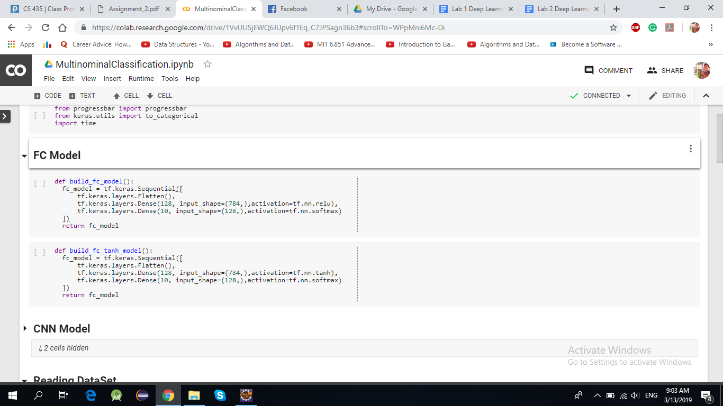

* Using Adam with lr=0.0009 We reached an accuracy for training set which is 98.49% and for testing set 97.71%, we tried regularization but there is no a remarkable change as there is no overfitting, it takes 37 second in running
* We tried another optimizer ( SGD ) but the results was not better than Adam
* We tried also tanh on FC model but Relu is better than tanh.  
  Relu is 97.71% while tanh reaches 97.01%

**CNN Model:**

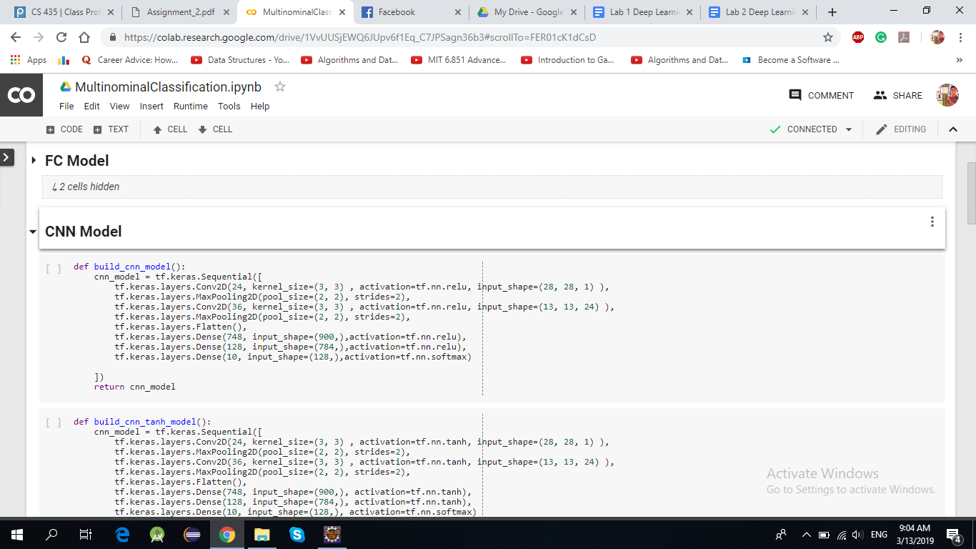

* Using Adam with lr= 0.0009 We reached an accuracy for training set which is 99.46% and for testing set 99.23%, we tried regularization but there is no a remarkable change as there is no overfitting, it takes 308 seconds in running
* We tried another optimizer ( SGD ) but the results was not better than Adam
* We tried also tanh on FC model but Relu is better than tanh.  
  Relu is 97.71% while tanh reaches 97.01%